Why did the Mary Rose Sink
The most likely reason for the loss of the Mary Rose is probably the most straightforward. In the heat of battle with the French galleys, perhaps the captain or the crew made a mistake.
It is claimed that the admiral called out that he had “the sort of men” that he “could not rule”, but this claim comes from his family, possibly trying to protect the family name?
Theory one-HUMAN ERROR

Theory2-THE WIND
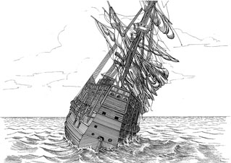
Did a gust of wind hit the sails at a crucial moment, making the ship unstable? Eye-witness accounts described a sudden breeze as the Mary Rose went to make the quickly

With the gun ports opened for battle, the ship could have flooded and quickly foundered. So why had she never foundered before? Perhaps she had simply become too heavy after a recent refit, which had added extra guns to her firepower.
Theory3-THE FRENCH
.
Theory 3 - The French
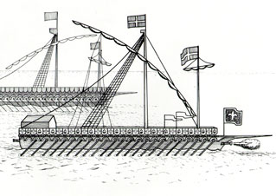
Although there is no archaeological evidence to confirm this, a French cavalry officer present at the battle stated that the Mary Rose had been sunk by French guns. A cannonball low in the hull would enable water to flood in, making the ship unstable and leading to her sinking.
Perhaps that was why the ship turned north so suddenly. Was she aiming to reach the shallows at Spit bank a few hundred metres away?
Theory 4 - Overloading
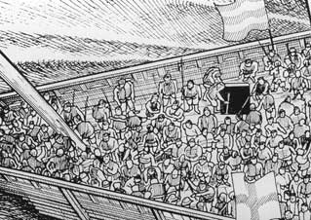
Was she overloaded with heavy guns or with extra soldiers? If so, a strong gust of wind could have heeled her over into the sea.
The guns had been put aboard in London, so she’d managed to traverse the English Channel without mishap, so why did she topple in the Solent?

Miss Martin says: Good research and ideas. 2 credits

.

----------------------------------------------------------------------------------------------------------------------------------

